SQL Server Database Diagram Tool in Management Studio

Tips and Hints:

You can use **SQL Servers Diagram Tool to** create or generate supporting **ERDs** as part of the Database Documentation process. Often neglected in Industry and is becoming an issue since the World Databases are growing exponentially.

Create simple database diagrams, screenshot and save the Image or copy into a Microsoft Word, PowerPoint or to PDF. Produce your Database Documentation to support your Development Team and Audience.

In this tip we will walk through how to create a database diagram using SSMS.

Using Microsoft’s sample database **WideWorldImporters,**

Diagram Tool Demo

Creating a simple **Database Diagram** for a limited number of tables focusing on **Invoice** and related tables in the database.  I’ll then copy the Database Diagram to MS Word so it can be saved and printed.

**Step 1 – New Database Diagram using SQL Server Management Studio**

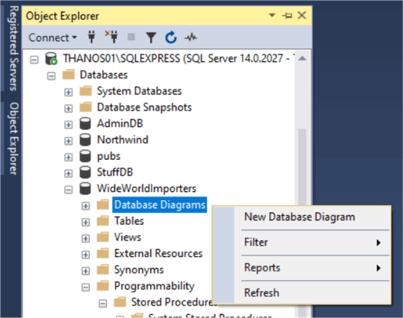

**Step 1:** In **SSMS** under the database **WideWorldImporters,**

* right click **"Database Diagrams"** and
* select **"New Database Diagram".**

**Step 2 – From Database Diagram – Select a table**

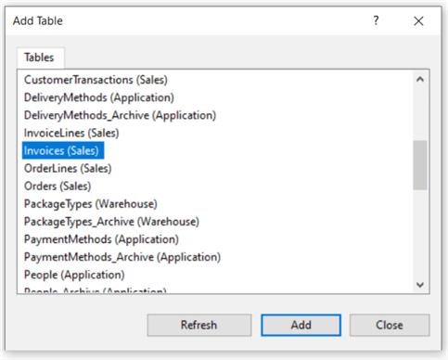

**Step 2:** From the **Database Diagrams tool dialog** for **Add Tables** scroll and select **Invoice** table. Press **Add** and then **Close**.

**Step 3 – From Database Diagram – Add Related tables**

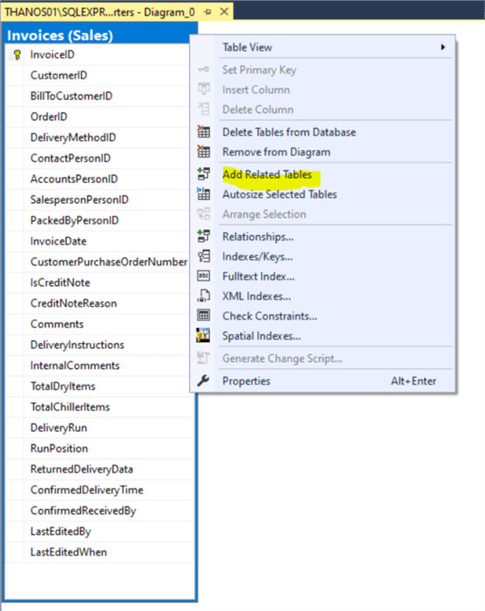

**Step 3:** **Right click** the **Invoices table** and select **"Add Related Tables"**. This automatically adds tables linked to the Invoices table by **Foreign Keys**.

**Step 4 – Eliminate Unwanted Tables from the Diagram**

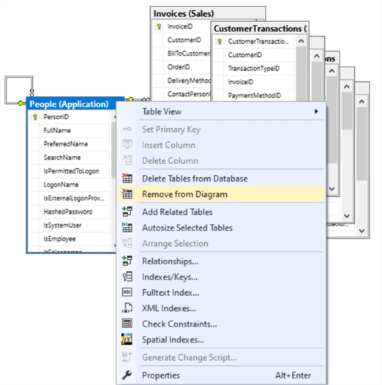

**Step 4:** Right click on any table that might clutter the diagram and that you feel is not important and select "**Remove From Diagram".**

**Step 5 – From Database Diagram – Auto Arrange Tables**

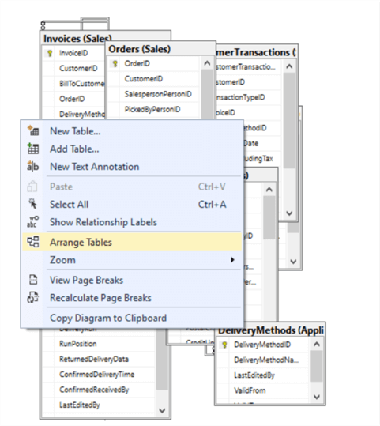

**Step 5:** Right click the **Invoices** table and select "**Arrange Tables**". This organizes the tables without overlapping.

**Tips and Hints:**

* SQL Server does not **Backup** and **Restore** SQL Server **Diagrams** when migrating your Databases.
* Provide several Diagrams rather than one large one.
* Try and provide focus in terms of Schemas or Related Tables.

**Step 6 – From Database Diagram – Adjust the Layout**

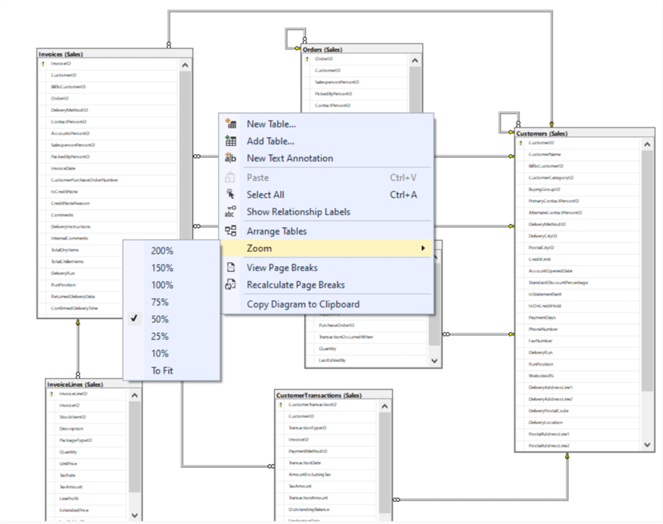

**Step 6:** You can do the following:

* Right click to select a Zoom level to see your tables.
* Drag a table to adjust the positioning.
* Click a table and put the cursor on the edge to resize the table layout.

**Step 7 – From Database Diagram – Auto Size All Tables**

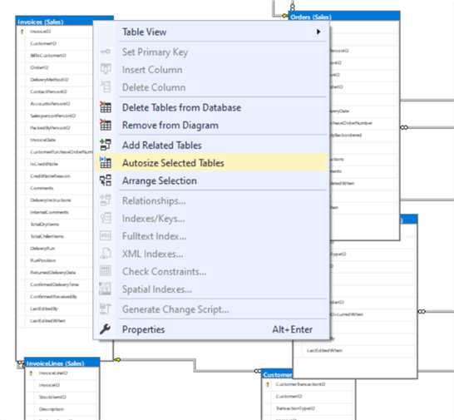

**Step 7:** Use **CTRL + A**to select all tables. Right click any highlighted table and select "**Autosize Selected Tables**". Select and drag the connector lines to rearrange.

**Step 8 – From Database Diagram – Copy to Clipboard**

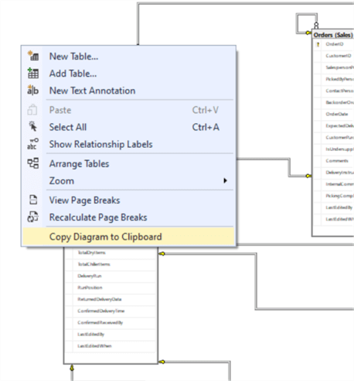

**Step 8:** Once the Diagram is sized and arranged as desired, hit Save and give your Diagram a name.  Then right click any white space in the Diagram and select "**Copy Diagram to Clipboard**".

**Step 9 – Paste the Diagram to MS Word**

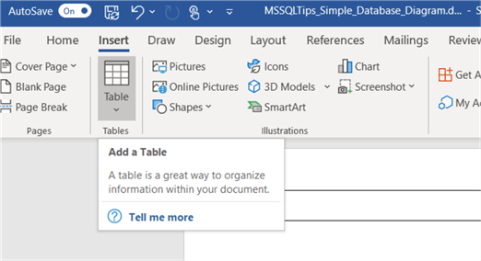

**Step 9:** Open Microsoft Word (or PowerPoint) and Insert a single cell Table and paste the Database Diagram in the cell.

Step 10 – In Word Adjust and Maximize the Database Diagram Image

Make sure it is legible!!!

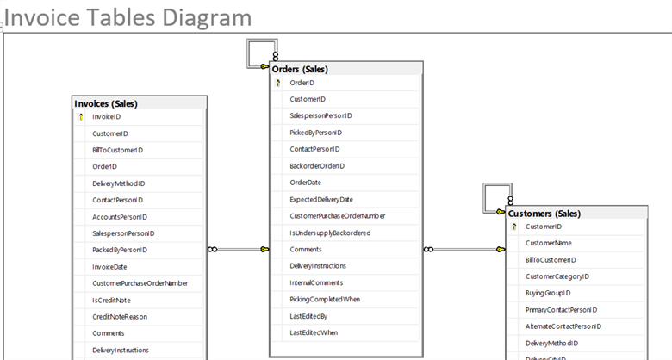

**Step10:** In Word Adjust and Maximize the Database Diagram Image

Adjust the Word document to maximize the database diagram image.  Change the margins to .5 inch, enter the image and resize it to enlarge. Below is a snippet from a Word document Database Diagram.

Wrap Up

Once the diagram is in Word you can print it, share it, or save as a Word Doc or PDF file.  This is an effective way to create simple limited Database Diagrams that can be leveraged when documenting your database.

I find creating partial database diagrams around logical groups of tables a good way to document a database.

There are other options that can be done in SSMS Database Diagrams such as only showing the **Table Names** and **Relationships** or only displaying the **Key Columns** which may allow more tables to be added to the Database Diagram and still fit in a Word document.